**Solution: Analysis by Programming Language**

In order to look at the number of entries and the number of posts by programming language, we need to make use of the .groupby() method. The key is combining .groupby() with the TAG column, which holds as our categories (the names of the programming languages).

If we .sum() the number of posts then we can see how many posts each programming language had since the creation of Stack Overflow.

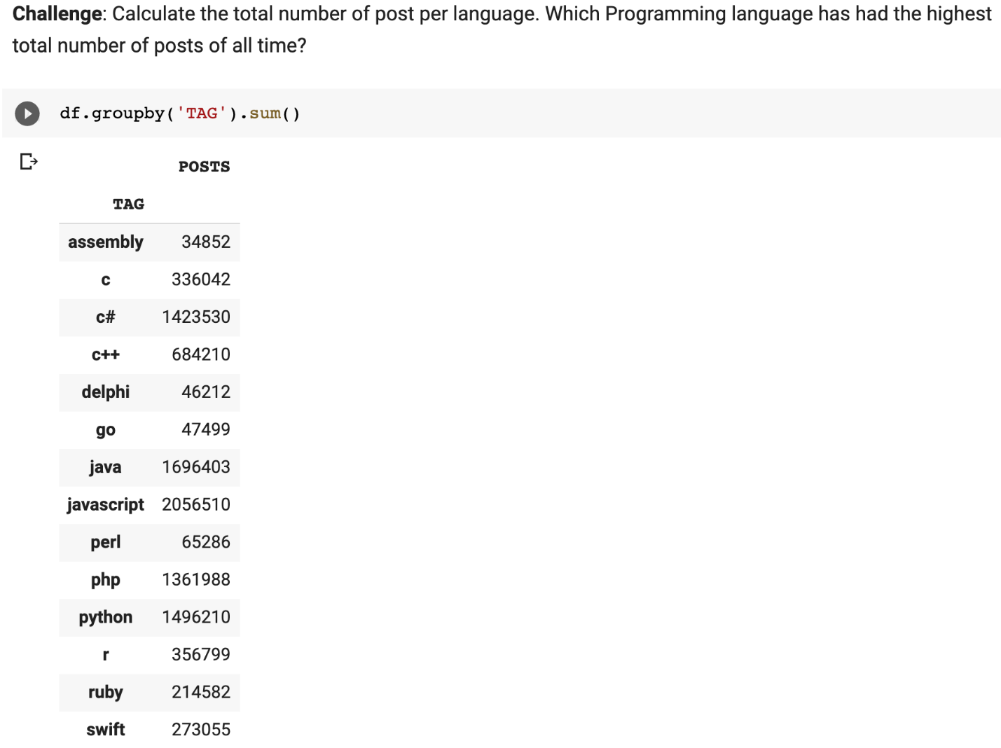

If we .count() the entries in each column, we can see how many months of entries exist per programming language.

